[Home](https://grobotronics.com/)/[Robotics](https://grobotronics.com/robotics/)/[Development Tools](https://grobotronics.com/robotics/development-tools-el/)/[WeMos, ESP32 & ESP8266](https://grobotronics.com/robotics/development-tools-el/wemos-lolin/)/ESP32 Development Board - DEVKIT V1

Top of Form

[[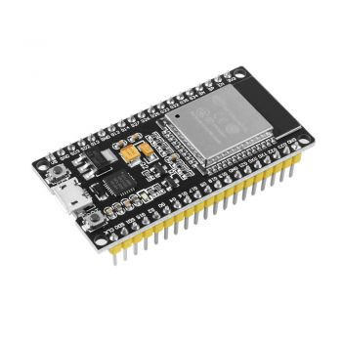](https://grobotronics.com/images/detailed/123/esp32-4-1_grobo.jpg)](https://grobotronics.com/images/detailed/123/esp32-4-1_grobo.jpg" \o "ESP32 Development Board - DEVKIT V1)

[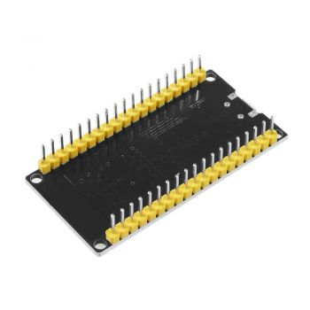](https://grobotronics.com/images/detailed/123/esp32-3_grobo.jpg)

[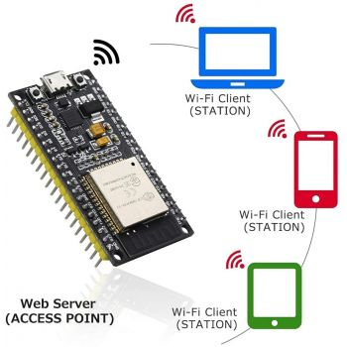](https://grobotronics.com/images/detailed/123/61yjg7wewwl._ac_sl1001__grobo.jpg)

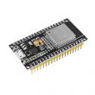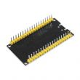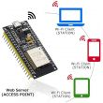

**ESP32 Development Board - DEVKIT V1**

by [OEM](https://grobotronics.com/oem.html)

The Esp32 DevKit v1 is one of the development board created to evaluate the ESP-WROOM-32 module. It is based on the  ESP32 microcontroller  that boasts...

SKU: 39-00011849

Gross Weight: 0.01kg

Warranty: Δεν καλύπτεται με εγγύση απο τον Κατασκευαστή

Company: [OEM](https://grobotronics.com/robotics/development-tools-el/wemos-lolin/?features_hash=14-5535)

Made in: China

Bottom of Form

**DESCRIPTION**

The Esp32 DevKit v1 is one of the development board created to evaluate the ESP-WROOM-32 module. It is based on the [ESP32 microcontroller](https://espressif.com/en/products/hardware/esp32/overview) that boasts Wifi, Bluetooth, Ethernet and Low Power support all in a single chip.

ESP32 is already integrated antenna and RF balun, power amplifier, low-noise amplifiers, filters, and power management module. The entire solution takes up the least amount of printed circuit board area.This board is used with 2.4 GHz dual-mode Wi-Fi and Bluetooth chips by TSMC 40nm low power technology, power and RF properties best, which is safe, reliable, and scalable to a variety of applications.

**Flash Layout**  
The internal flash of the ESP32 module is organized in a single flash area with pages of 4096 bytes each. The flash starts at address 0x00000, but many areas are reserved for Esp32 IDF SDK. There exist two different layouts based on the presence of BLE support.

**Power**  
Power to the Esp32 DevKit v1 is supplied via the on-board USB Micro B connector or directly via the “VIN” pin. The power source is selected automatically.

The device can operate on an external supply of 6 to 20 volts. If using more than 12V, the voltage regulator may overheat and damage the device. The recommended range is 7 to 12 volts.

**Connect, Register, Virtualize and Program**  
The Esp32 DevKit v1 comes with a serial-to-usb chip on board that allows programming and opening the UART of the ESP32 module. Drivers may be needed depending on your system (Mac or Windows) and can be download from the official [Espressif documentation page](https://docs.espressif.com/projects/esp-idf/en/latest/esp32/get-started/establish-serial-connection.html" \t "_blank). In Linux systems, the DevKit v1 should work out of the box.

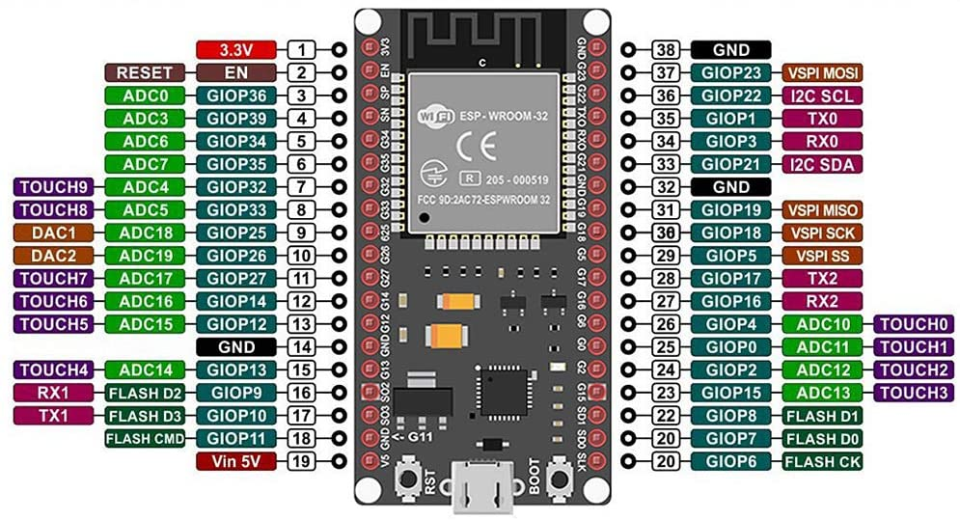

**SPECIFICATIONS**

Warranty:

Δεν καλύπτεται με εγγύση απο τον Κατασκευαστή

Company:

OEM

Gross Weight:

0.01kg

Made in:

China

**SPECIFICATIONS**

* Microcontroller: Tensilica 32-bit Single-/Dual-core CPU Xtensa LX6
* Operating Voltage: 3.3V
* Input Voltage: 7-12V
* Digital I/O Pins (DIO): 25
* Analog Input Pins (ADC): 6
* Analog Outputs Pins (DAC): 2
* UARTs: 3
* SPIs: 2
* I2Cs: 3
* Flash Memory: 4 MB
* SRAM: 520 KB
* Clock Speed: 240 Mhz
* Wi-Fi: IEEE 802.11 b/g/n/e/i:
  + Integrated TR switch, balun, LNA, power amplifier and matching network
  + WEP or WPA/WPA2 authentication, or open networks
* Dimensions: 51.5x29x5mm

